Guorun Huang, Project4 Report

Pattern Recognition and Computer Vision, 25Fall

**1. Project Overview**

In this project, I implemented a complete camera calibration and augmented reality pipeline using OpenCV.

The system first detects and extracts chessboard corners from video frames, allowing the user to select specific frames for calibration. The selected 2D corner positions are stored along with their corresponding 3D world coordinates, enabling computation of the camera matrix, distortion coefficients, and pose (rotation and translation) using solvePnP. The pose results behaved as expected: moving the chessboard sideways changed the X translation, moving it forward or backward affected Z, and tilting it resulted in rotation changes. Because the camera was fixed and the chessboard was handheld and slightly curved, minor inaccuracies occurred and distortion coefficients increased due to modeling assumptions being violated.

Using the estimated pose, I projected 3D axes and later created a virtual object—a tree and a rotating windmill—anchored to the chessboard in real time. I also experimented with robust feature detection using Harris, GFTT, FAST, ORB, and SIFT, and observed that adjusting thresholds and limiting feature count greatly improved detection quality.

Finally, I explored visual extensions, concluding that texture replacement on the detected board produces the best visual results compared to other attempted effects.

1. **Results**

**1 Detect and Extract Target Corners**

I am using the chessboard target. I defined my corner container as: std::vector<std::vector<cv::Point2f>> corner_list; ... corners_found = cv::findChessboardCorners(...)

This structure was chosen because I was planning for the possibility of detecting corners from multiple patterns or multiple frames.

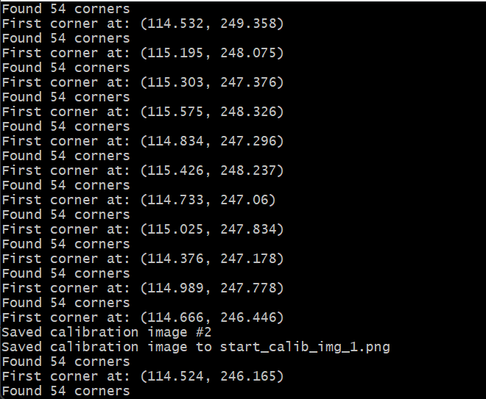

A limitation of the chessboard pattern is that detection accuracy decreases when the pattern is partially showed, or poorly illuminated as showed below.

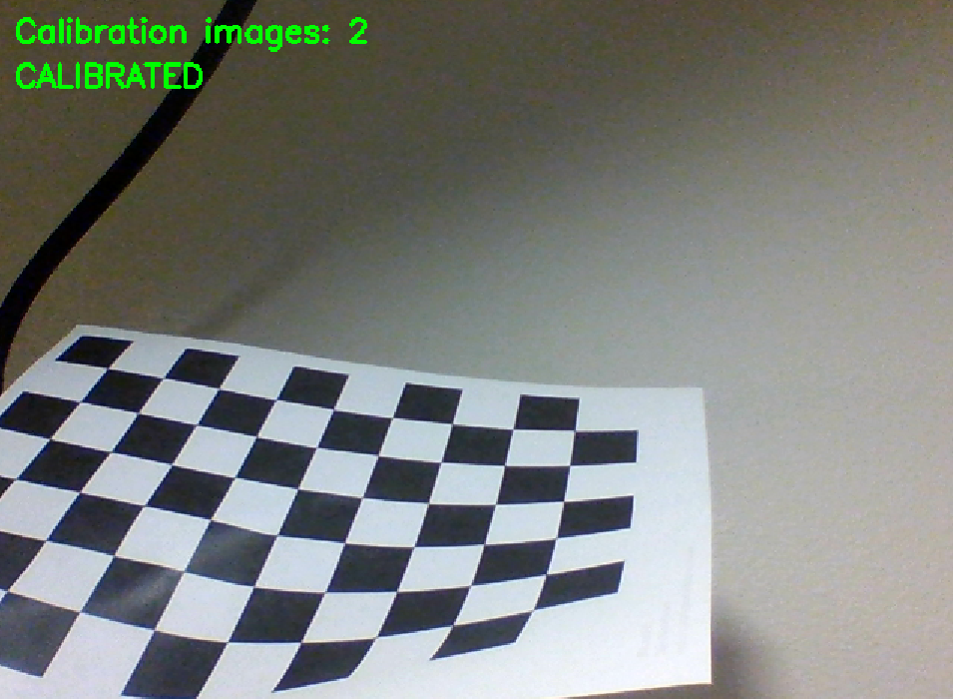

**2 Select Calibration Images**

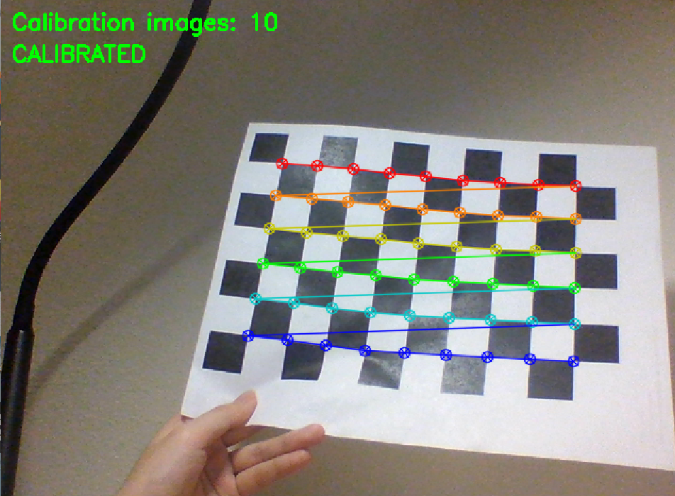

**3 Calibrate the Camera & 4 Calculate Current Position of the Camera**

Camera_matrix, distortion_coefficients, Rotation, and Translation parameters:

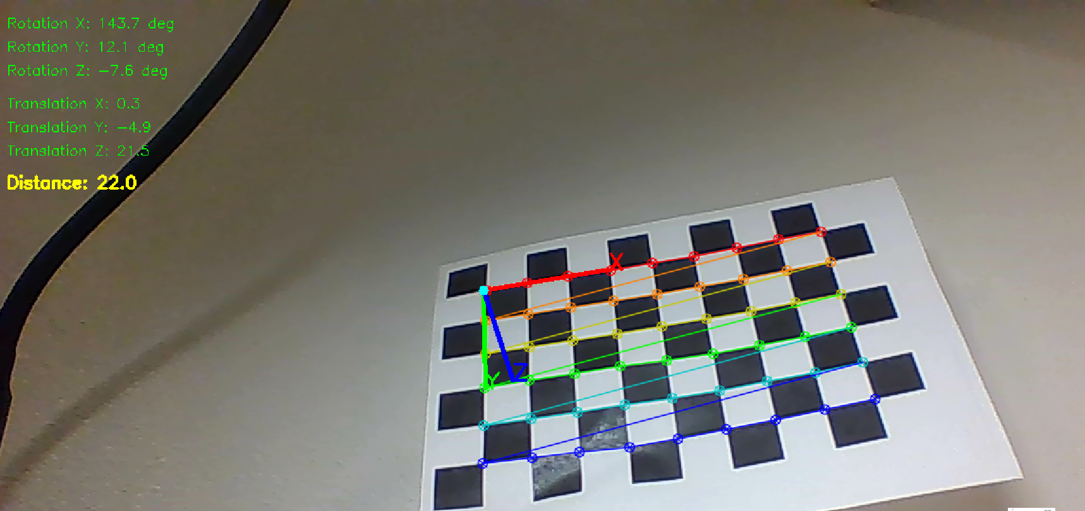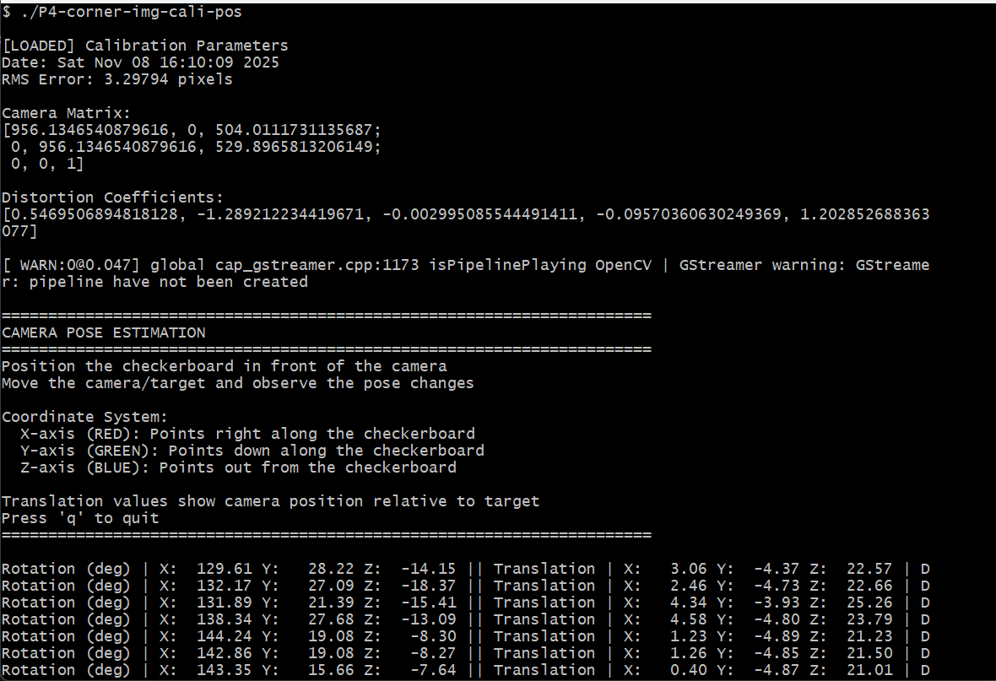

Calibration data.

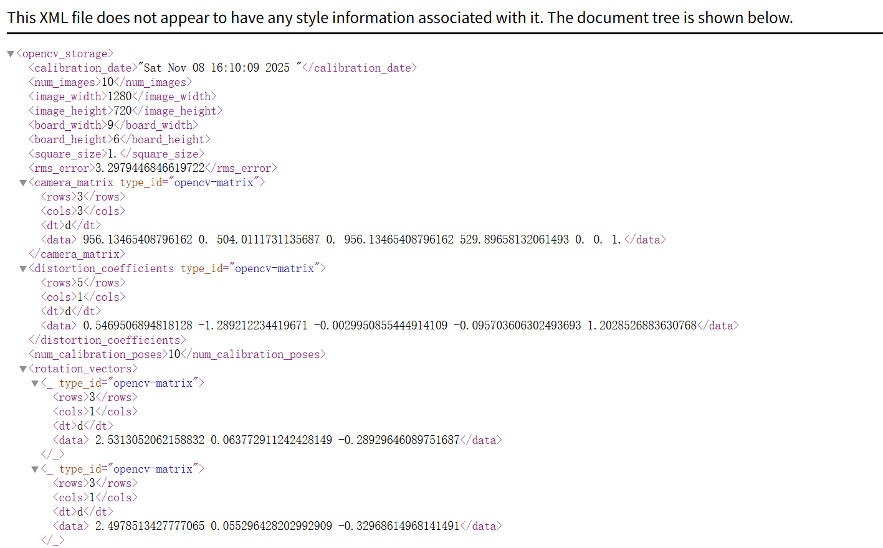

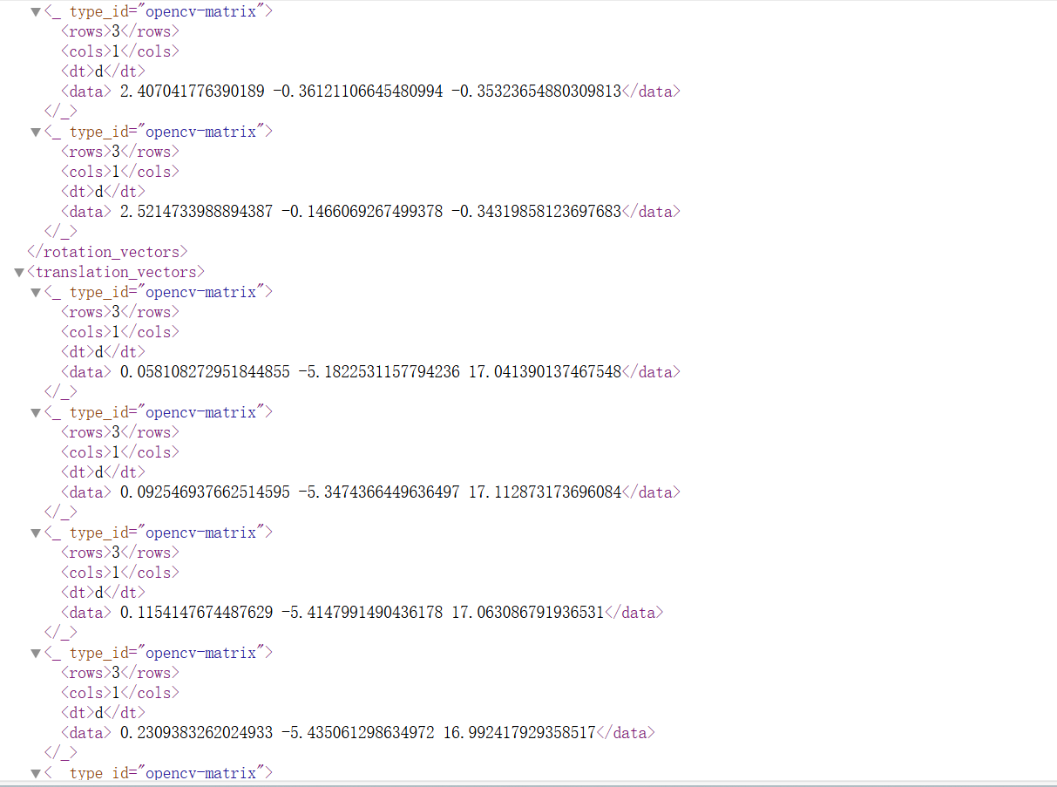

When I move the chessboard sideways (left or right), the translation vector changes mainly in the X-direction. When I move the chessboard forward or backward, the Z-value of the translation vector changes. Moving closer decreases Z, moving farther increases Z, which is consistent with the camera's distance from the board. When I tilt the chessboard, the rotation vector changes significantly (especially around the X or Y axis), reflecting the new orientation.

These changes match physical expectations. Translation reflects how far the camera is from the target, and rotation reflects orientation.

**Reflection:**

The important point is that I am using a fixed laptop camera and a movable chessboard target. In the real world, I am moving the chessboard. However, during calibration the algorithm assumes that it is the camera that is moving.

Why distortion coefficients might end up larger in practice:  
Distortion coefficients are properties of the lens. They should not systematically depend on whether the board or camera moved. However the optimizer that fits intrinsics+extrinsics minimizes reprojection error over all images. If the input images violate modeling assumptions, the optimizer can increase distortion terms to reduce reprojection residuals. In this case, pattern is not flat (curled paper). Calibration will partly absorb that into larger distortion coefficients.

**5 Project Outside Corners or 3D Axes**

Noticed that, the printed paper target(chessboard) was held by hand during corner detection, so it was not perfectly flat and had slight curvature. This caused small deviations in the detected corners and in the drawn coordinate axes.

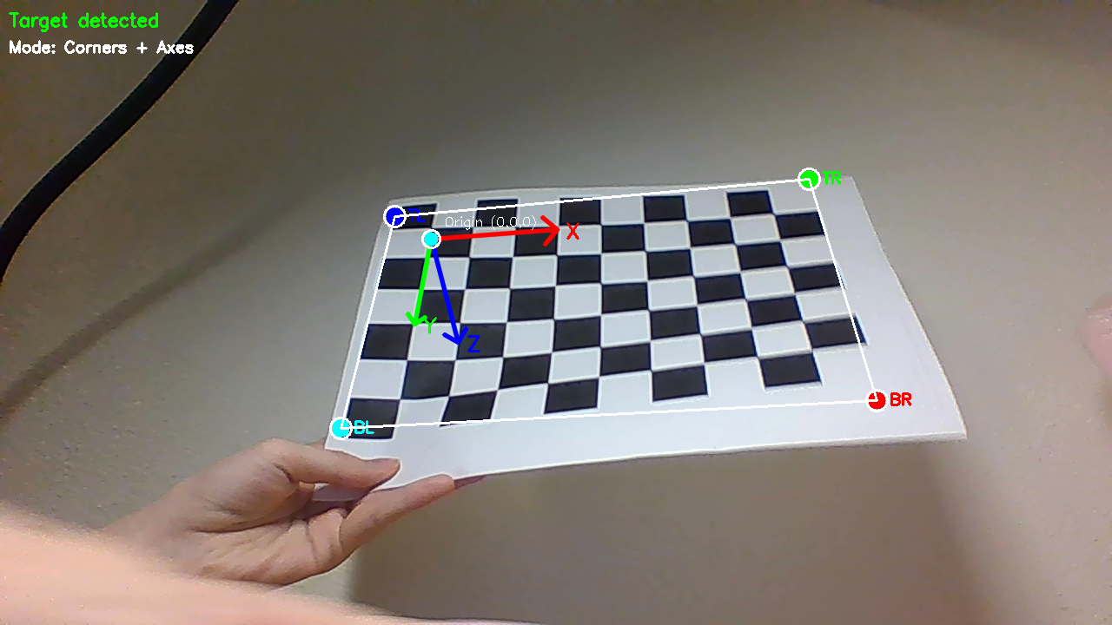

**6 Create a Virtual Object**

I created a tree and a rotating windmill.

The tree is generated by using center location (X, Y), trunk height, and trunk width to calculate the four bottom corner points and the four top corner points of the trunk. These points are connected to form the edges of the tree trunk. The tree canopy is built using a stacked-pyramid structure. For each layer, four bottom corner points and a single top point are defined, and these points are connected to form the leaf shape above the trunk.

The windmill is created by defining a tapered tower and placing the rotating blades slightly above the top of the tower. A continuous animation timer is used to generate the blade rotation angle with float angle = animation_time * 2.0f; and animation_time += 0.05f;. Each blade receives an additional 90-degree offset using float blade_angle = angle + i * CV_PI / 2.0f;, allowing the blades to rotate smoothly around the tower.

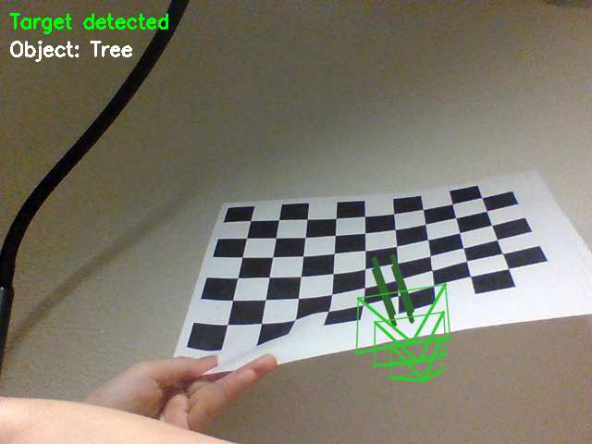

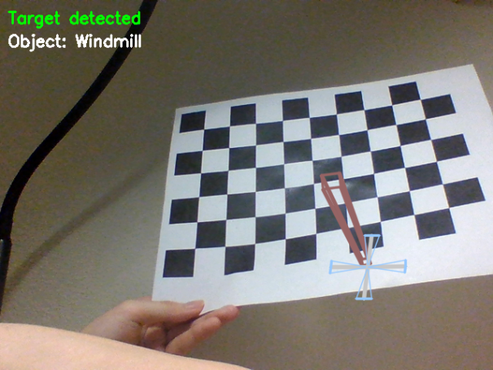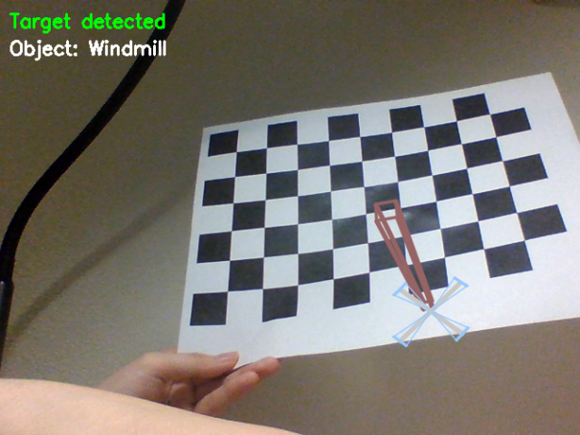

**7 Detect Robust Features**

Initially, I set the threshold for the Harris corner detector to 100, which caused the entire window to be filled with green points, making both the background and the chessboard invisible. This indicated that the threshold was too low. After increasing it to 200, the detection became much cleaner and the result improved noticeably. I tested multiple feature detection methods, including Harris, GFTT, FAST, ORB, and SIFT. By adjusting the threshold and limiting the number of detected features, the detection quality can be optimized.

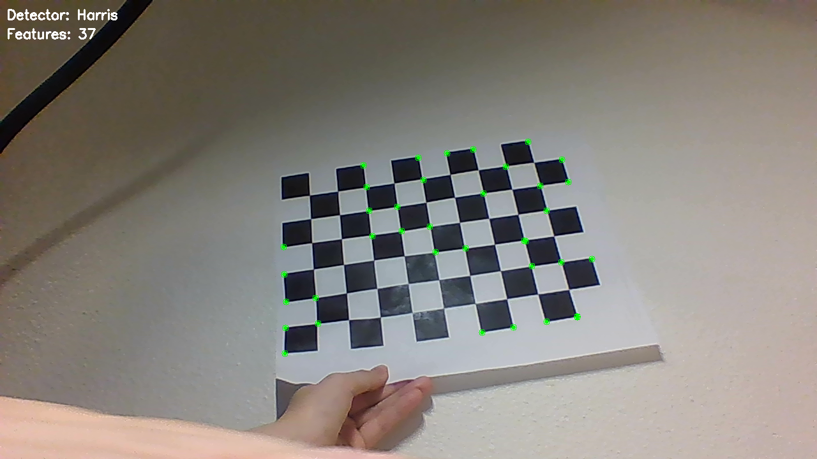

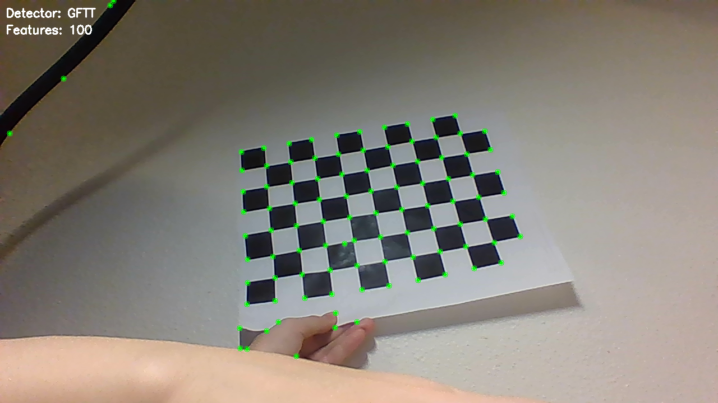

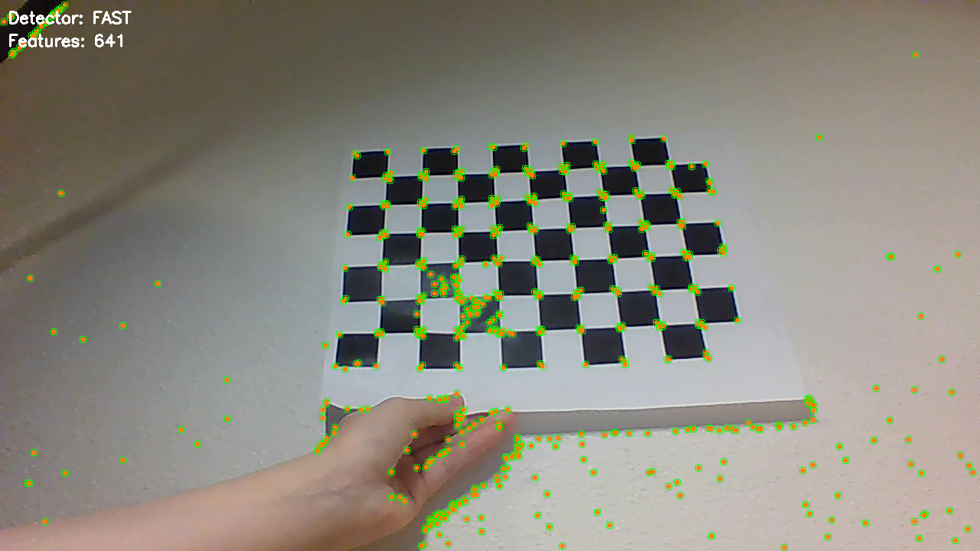

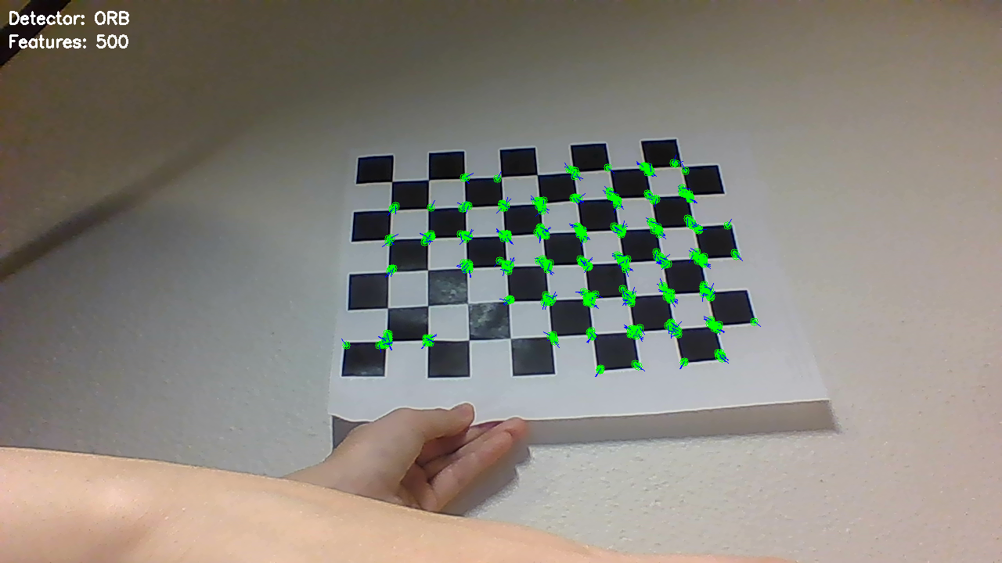

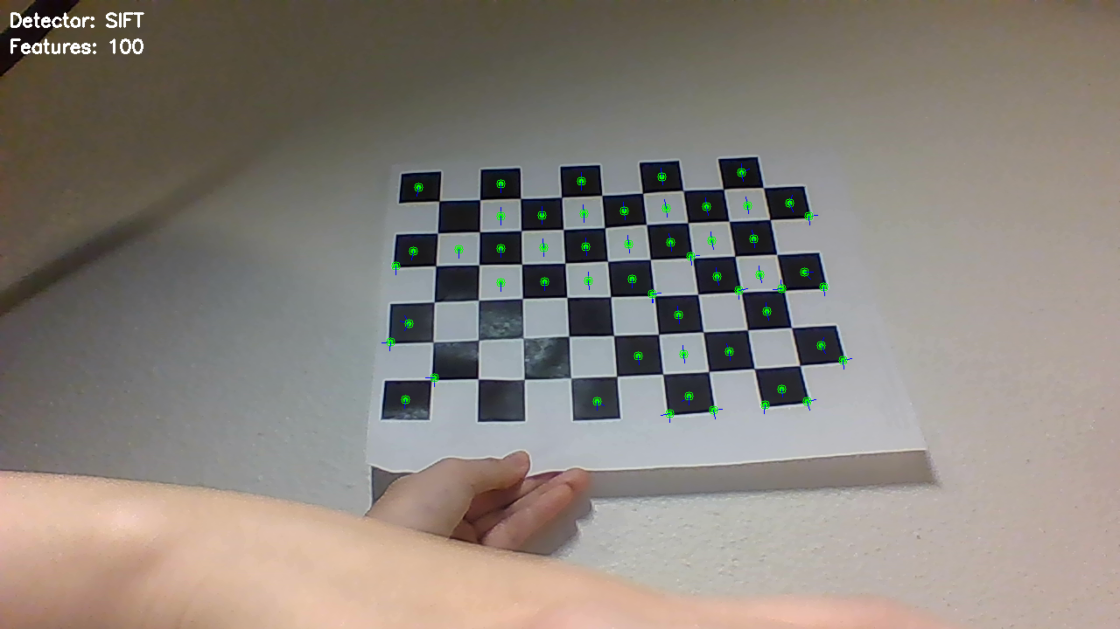

**8 Extention**

Tried several , doesn’t work：Simple Blur - Blur out the checkerboard， Inpainting - Fill with surrounding content， Glitch Effect

Works well: Texture Replacement - Replace with realistic texture

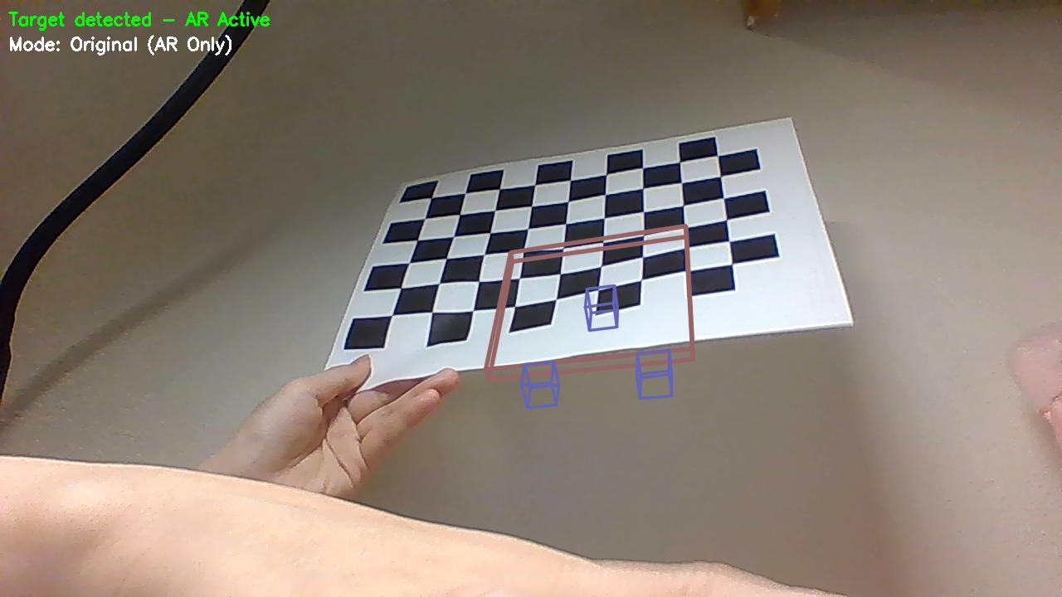

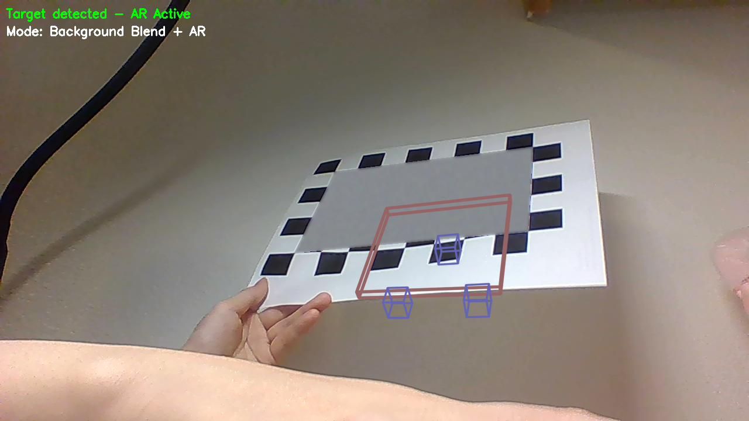

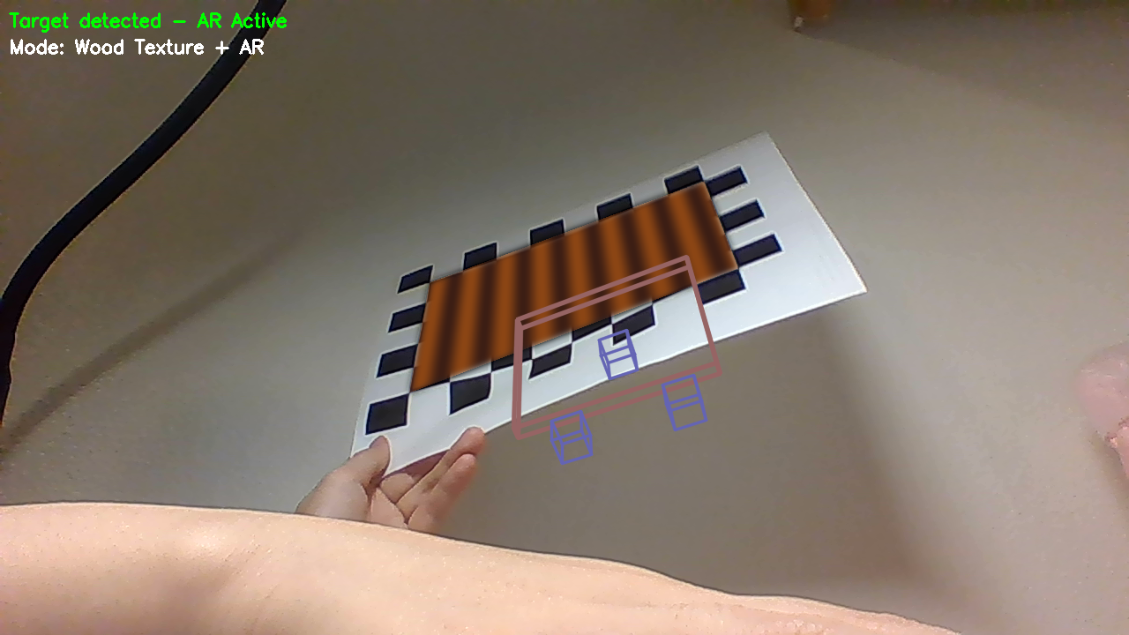

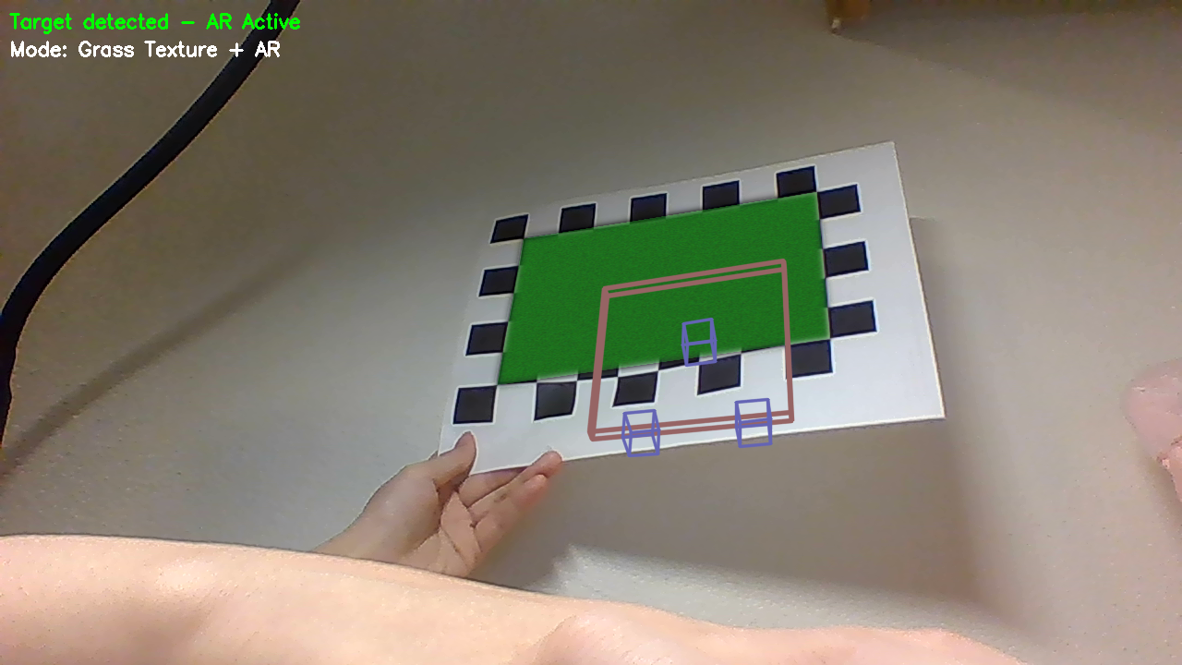

1. **Acknowledgements**

Thanks to Professor Maxwell (the demonstration for Project4 on class were essential for the experiments) and the TA Sihe for his support. I also referred to the official OpenCV documentation, Stack Overflow discussions, and various online tutorials throughout the project.